**WEB TECHNOLOGIES  
  
CRUD OPERATIONS ASSIGNMENT**

1. **Fahad Saeed  
   SP23-BSE-115  
   Section C**

**API USED: https://usmanlive.com/wp-json/api/stories/**

**HTML**



**CSS**



**JS**



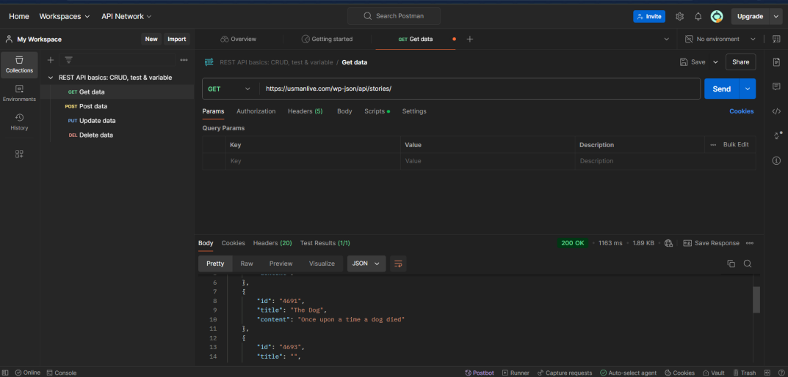**GET**

**PUT**

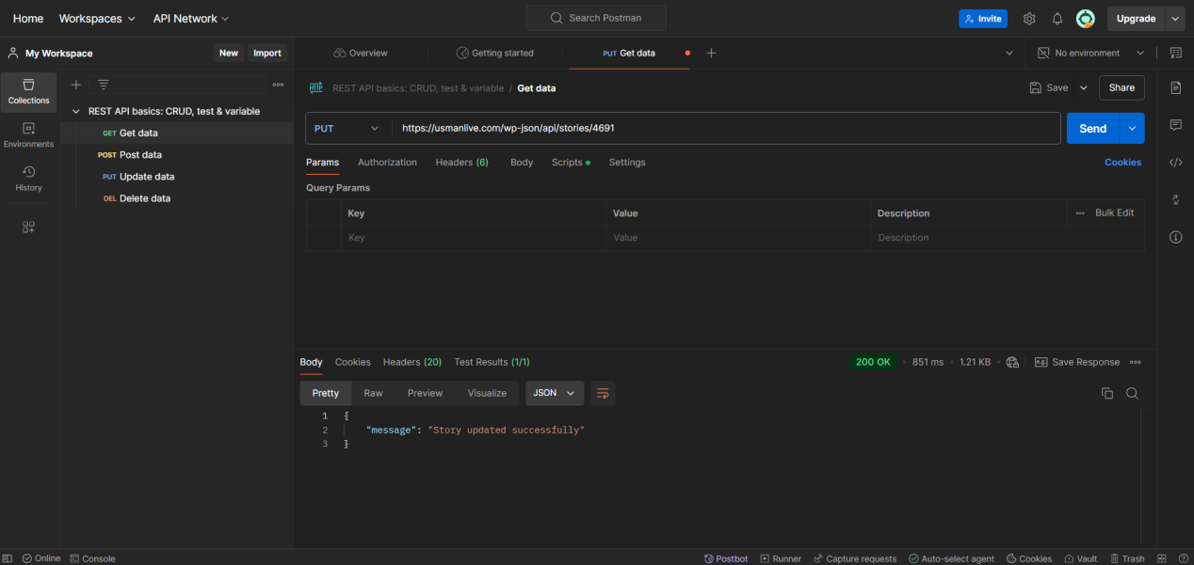

**POST  
  
 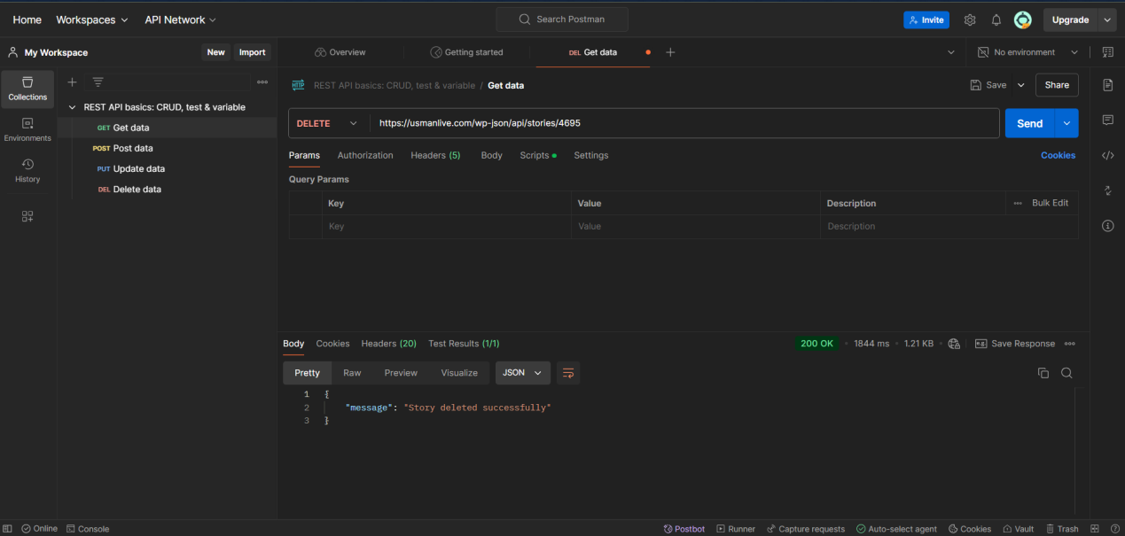**

**DELETE**

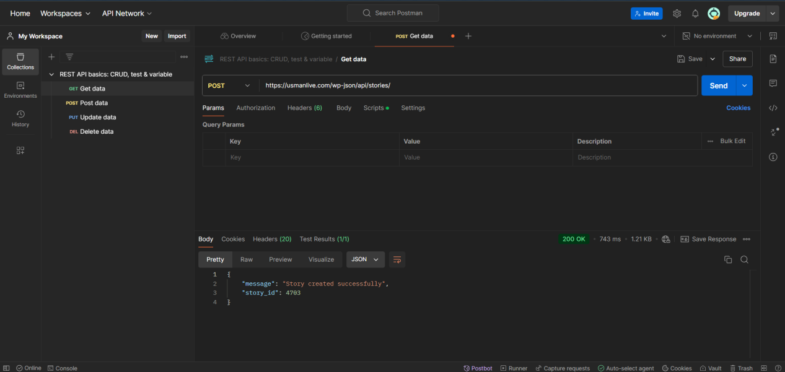

**Front End**

